INSTRUCTION FOR SHT VENTILATION FAN
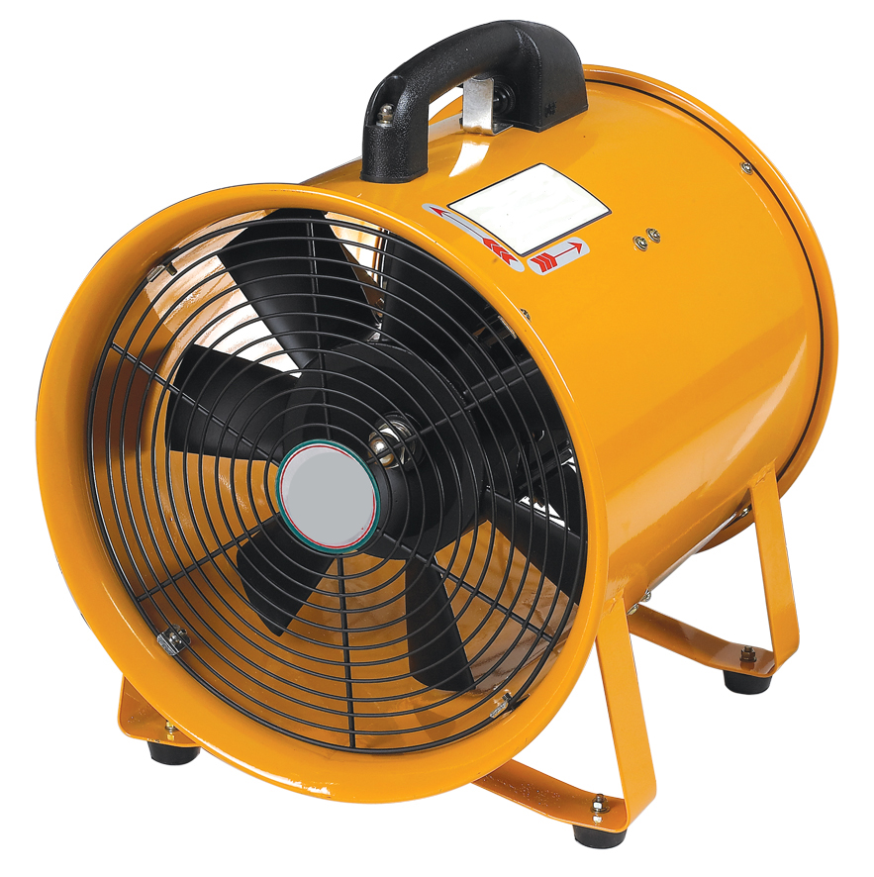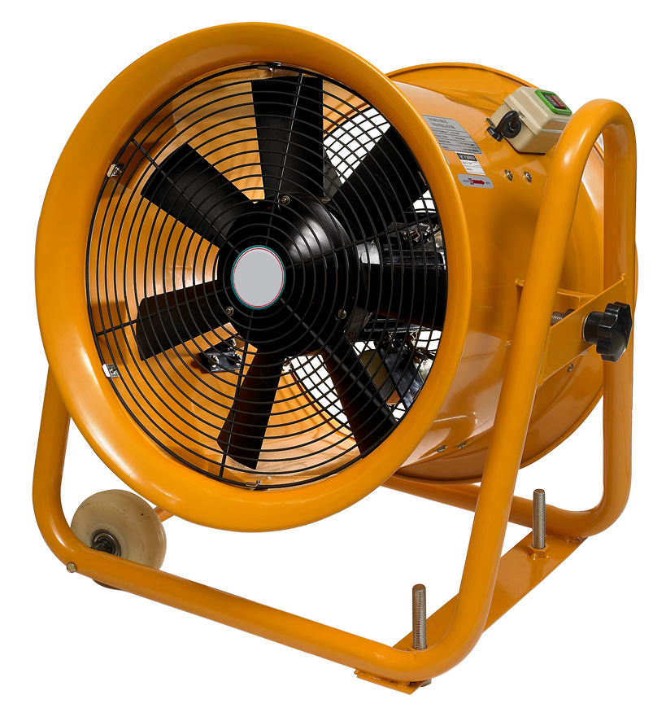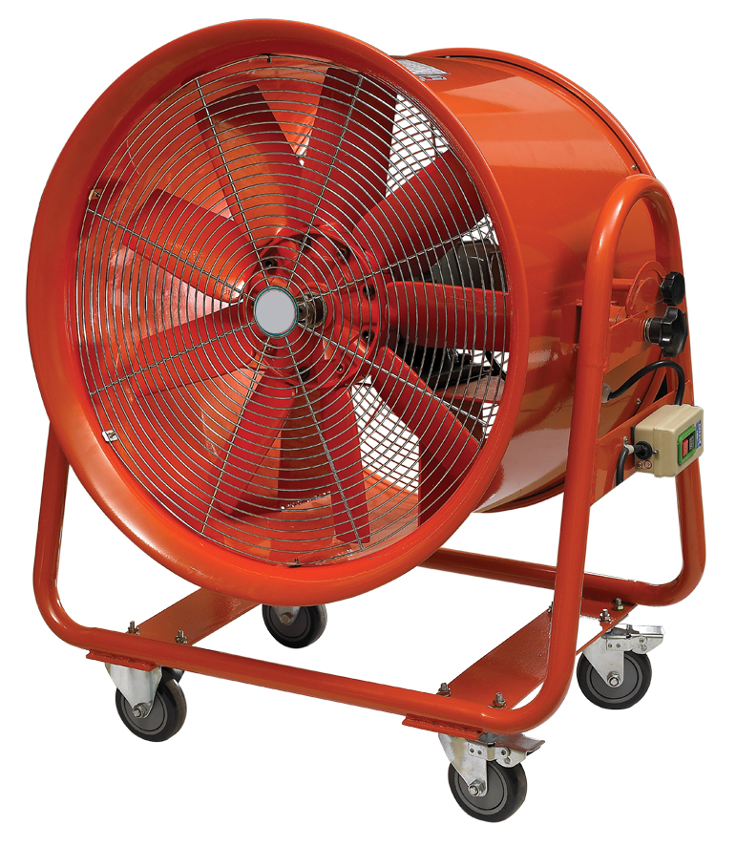
Our SHT series propeller ventilation fan has many strong points such as excellent function, special style, light weight, strong wind-power and reasonable structure. It’s special manufactured for cabin, cable maintain and in other violent working situation for ventilation.
WARNING AND SAFETY GUIDELINES
1) Do not use under flammable and explosive environment avoid the exploding.
2) Keep out of the way of any dangerous, it must to avoid the back-flow of gases into the room from the open flue of gas or other open-fire appliances.
3) The ventilator must be earthed, avoid any danger.
4) This appliance can be used by children aged from 8 years and above and persons with reduced physical, sensory or mental capabilities or lack of experience and knowledge if they have been given supervision or instruction concerning use of the appliance in a safe way and understand the hazards involved. Children shall not play with the appliance. Cleaning and user maintenance shall not be made by children without supervision.
5) The appliance is not to be used by persons (including children) with reduced physical, sensory or mental capabilities, or lack of experience and knowledge, unless they have been given supervision or instruction. Children being supervised not to play with the appliance.
6) Ensure that the fan is switched off from the supply mains before removing the guard.
7) If the supply cord is damaged, it must be replaced by the manufacturer, its service agent or similarly qualified persons in order to avoid a hazard.
8) A disconnection incorporated in the fixed wiring is to be provided
ENVIRONMENT OF USE
- The max relative humidity is 90%(when in 25℃)；
- Below 1000 meters altitude, use indoor
USE AND MAINTAIN
- Make sure the ventilator’s voltage in accordance with local voltage before use.
- Ventilator only could be use in ordinary indoor situation, but not at high humidity situation for fear cause and safety hidden trouble.
- Please find a professional maintenance man to rub the lube in machinery axletree after the ventilator has used 1000 hours, to ensure the ventilator has long-life.
- If the supply cord is damaged it must be replaced by a special cord or assembly available from the manufacture or its service agent.
- It must be return to sale agent or repaired by expert when the ventilator needs repaired.
NOTE
- The ventilator must be used indoor.
- Children or handicapped use this product in accompany with adult.
- Cut off the power before any cleaning and maintenance.
CIRCUIT DIAGRAM
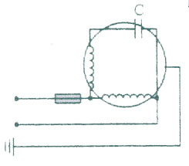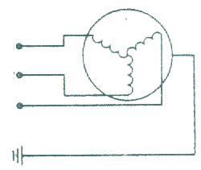
Temperature Protector:110°/6A
L1
L2
L3
(220-240V/50Hz,110V/60Hz)
(380V-415/50Hz)
COMPONENT FOR SHT3 SERIES
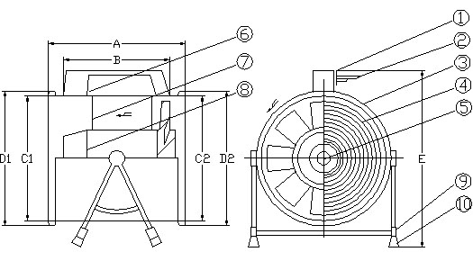
 | Parts Name
1 | Handle
2 | Wire
3 | Casting
4 | Safety Guard
5 | Blade
6 | Switch
7 | Motor Chasis
8 | Motor
9 | Fan Chasis
10 | Absorber Pad

FUNCTION PARAMETER LIST
Model | MM | VOLTAGE | Hz | W | r/min | M³/min | Pa | dB(A)
SHT-20 | Ф200 | 220-240/380-415 | 50/60 | 230 | 2800 | 25 | 245 | 60
SHT-20 | Ф200 | 110 | 60 | 230 | 3300 | 25 | 245 | 60
SHT-25 | Ф250 | 220-240/380-415 | 50/60 | 320 | 2800 | 43 | 294 | 68
SHT-25 | Ф250 | 110 | 60 | 320 | 3300 | 43 | 294 | 68
SHT-30 | Ф300 | 220-240/380-415 | 50/60 | 520 | 2800 | 65 | 373 | 71
SHT-30 | Ф300 | 110 | 60 | 520 | 3300 | 65 | 373 | 71
SHT-35 | Ф350 | 220-240/380-415 | 50/60 | 750 | 2800 | 82 | 598 | 76
SHT-35 | Ф350 | 110 | 60 | 1000 | 3300 | 82 | 598 | 76
SHT-40 | Ф400 | 220-240/380-415 | 50/60 | 1100 | 2800 | 96 | 700 | 80
SHT-40 | Ф400 | 110 | 60 | 1800 | 3300 | 96 | 700 | 80
SHT-45 | Ф450 | 220-240/380-415 | 50 | 1500 | 2800 | 162 | 972 | 83
SHT2-40 | Ф400 | 220-240/380-415 | 50 | 1100 | 2800 | 96 | 700 | 80
SHT2-40 | Ф400 | 110 | 60 | 1800 | 3300 | 96 | 700 | 80
SHT2-50 | Ф500 | 220-240/380-415 | 50 | 1800 | 2800 | 200 | 1050 | 88
SHT2-50 | Ф500 | 110 | 60 | 2500 | 3300 | 200 | 1050 | 88
SHT2-60 | Ф600 | 220-240/380-415 | 50 | 2200 | 1400 | 290 | 1100 | 92
SHT3-20 | Ф200 | 220-240/380-415 | 50/60 | 230 | 2800 | 25 | 245 | 60
SHT3-20 | Ф200 | 110 | 60 | 230 | 3300 | 25 | 245 | 60
SHT3-25 | Ф250 | 220-240/380-415 | 50/60 | 320 | 2800 | 43 | 294 | 68
SHT3-25 | Ф250 | 110 | 60 | 320 | 3300 | 43 | 294 | 68
SHT3-30 | Ф300 | 220-240/380-415 | 50/60 | 520 | 2800 | 65 | 373 | 71
SHT3-30 | Ф300 | 110 | 60 | 520 | 3300 | 65 | 373 | 71
PLACE FOR USING FLEXIBLE DUCT OPERATION
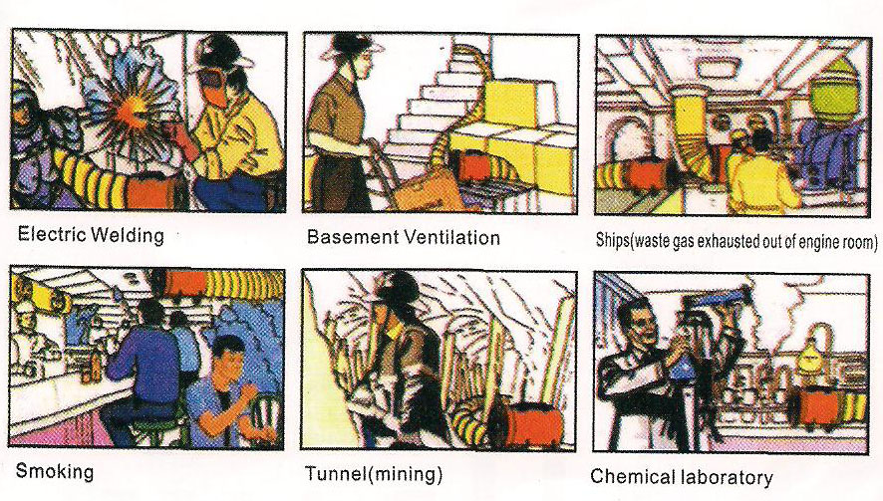
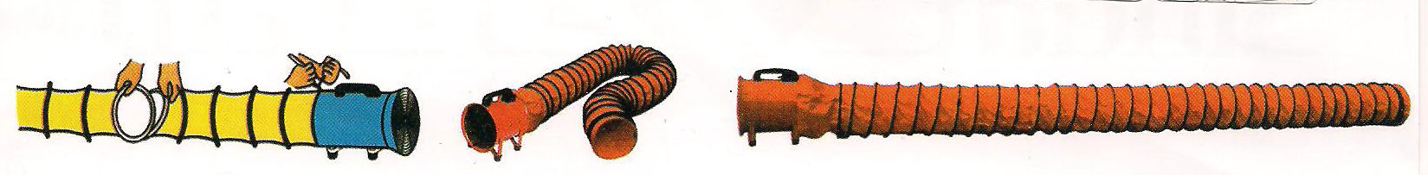
Model | Ф200 | Ф250 | Ф300 | Ф350
Length(M) | 5/10M | 5/10M | 5/10M | 5/10M

Model | Ф400 | Ф450 | Ф500 | Ф600
Length(M) | 5/10M | 5/10M | 5/10M | 5/10M

